

**Mawlana Bhashani Science and Technology University**

**Lab-Report**

Report No: 04

Course code: ICT-4202

Course title: Wireless and Mobile Communication Lab

Date of Performance: 11.09.2020

Date of Submission: 18.09.2020

**Submitted by Submitted To**

Nazrul Islam

Assistant Professor

Dept. of ICT

MBSTU.

Name: AL AMIN

ID:IT-15019

4th year 2ndsemester

Session: 2015-2016(14-15)

Dept. of ICT

MBSTU.

**Experiment No: 04**

**Experiment Name: Protocol Analysis with Wireshark**

**Objectives:**

* Capture live packet data from a network interface.
* Display packets with very detailed protocol information.
* Filter packets on many criteria.
* Search for packets on many criteria.
* Colorize packet display based on filters.
* Create various statistics.

**Capturing Packets:**

By clicking Capture menu the process of capturing will be started. It will show the available interfaces list. Then, we need to start Capturing on interface that has IP address

The packet capture will display the details of each packet as they were transmitted over the wireless LAN.

Capturing can be stopped by clicking on Stop the running capture button on the main toolbar.

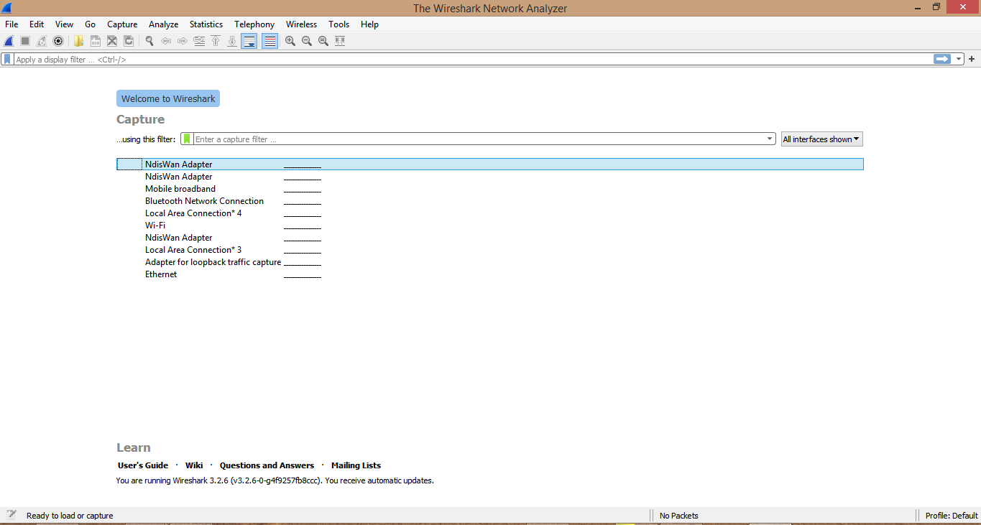

**Figure. Wireshark Interface**

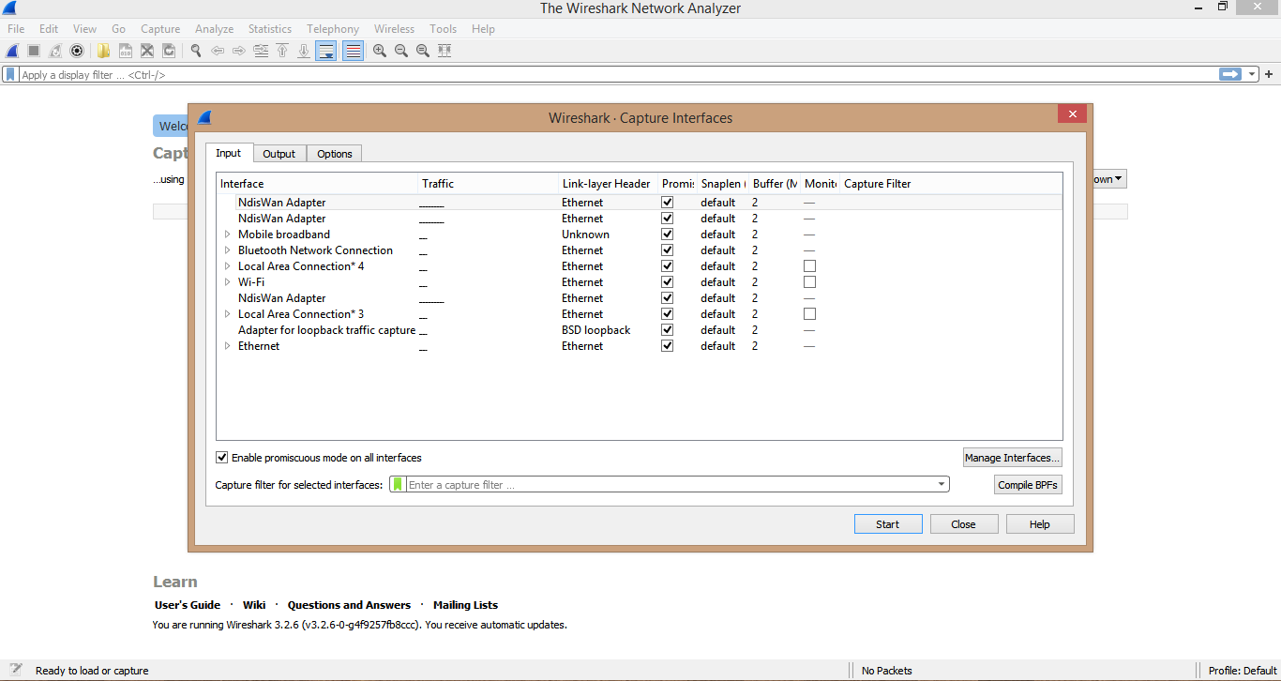

**Figure : Start Capturing Interface that has IP address**

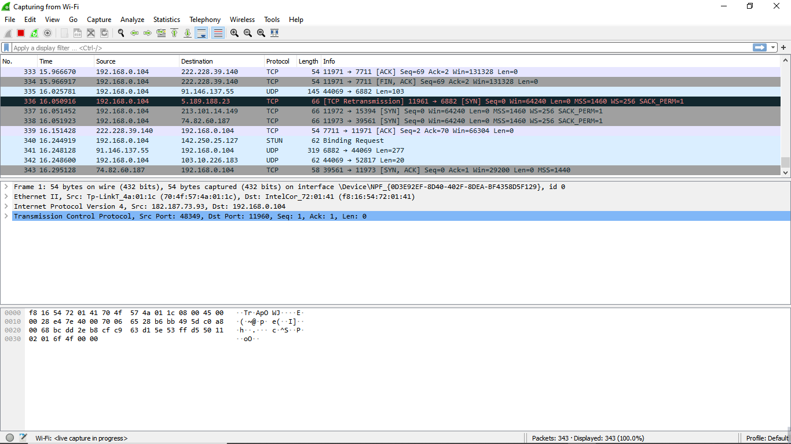

**Figure: sample packet capture window**

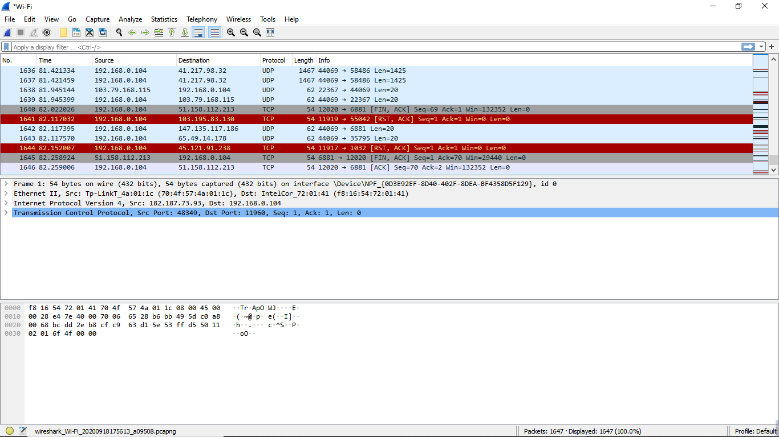**Figure: Stop Capture**

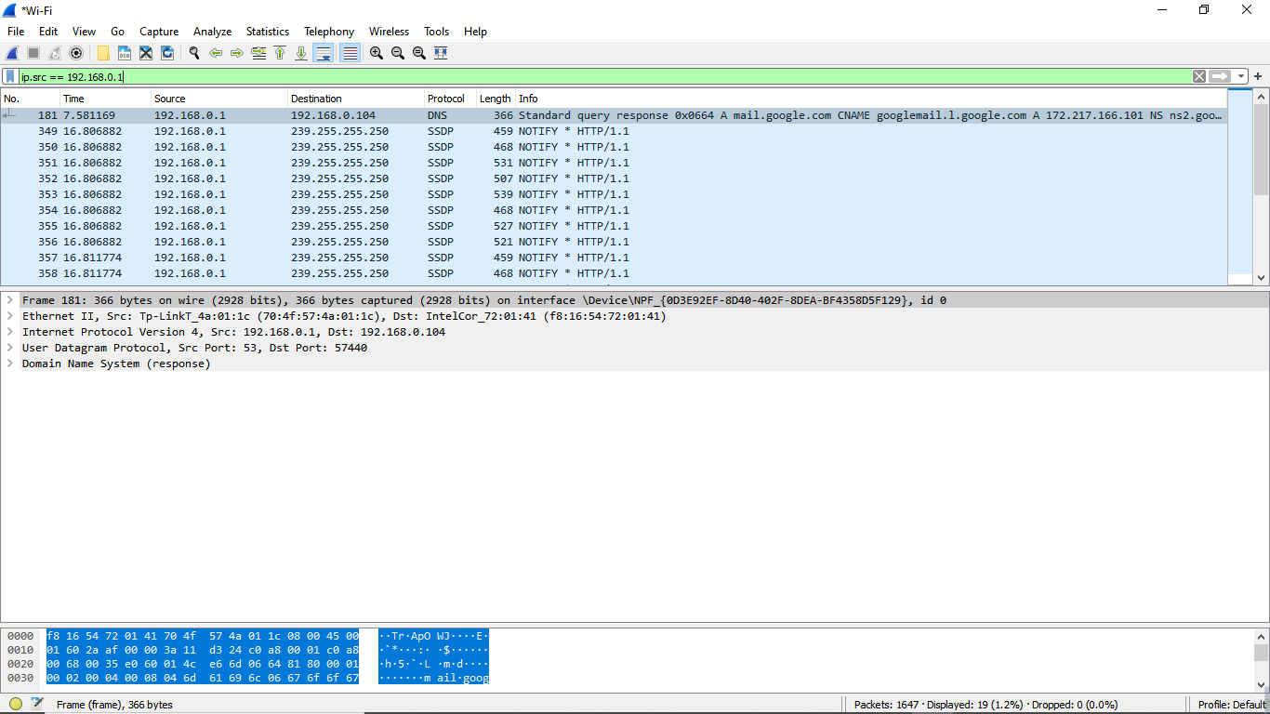

**Figure : Source IP filter**

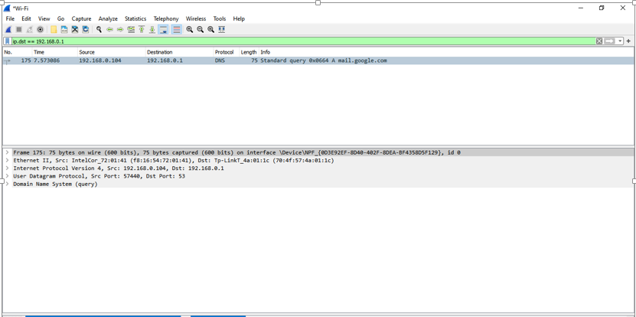

**Figure : Destination IP filter**

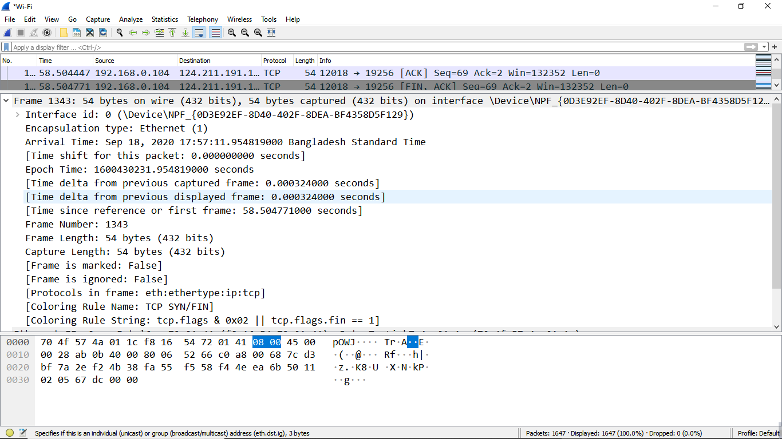

**Figure : Packet Details Pane(Frame segment)**

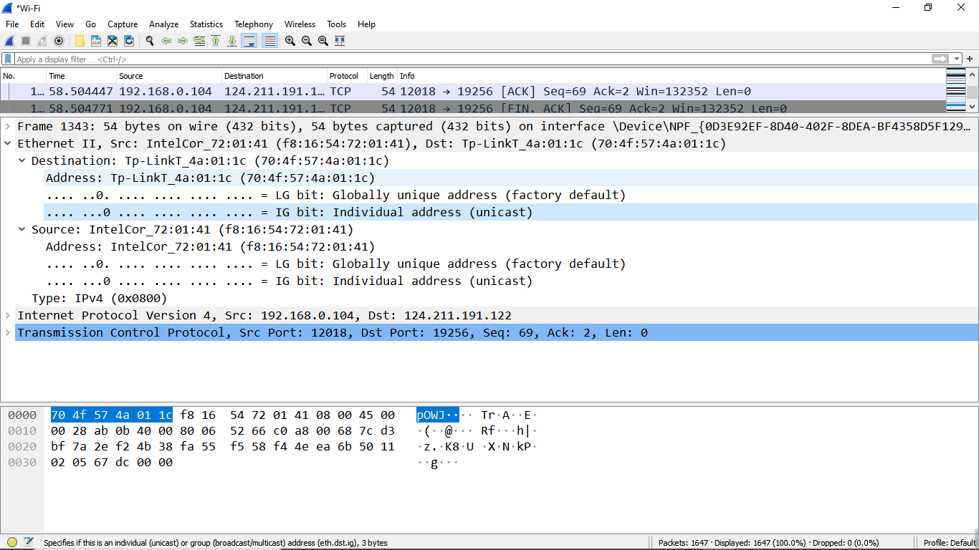

**Figure : Packet Details Pane (Ethernet Segment)**

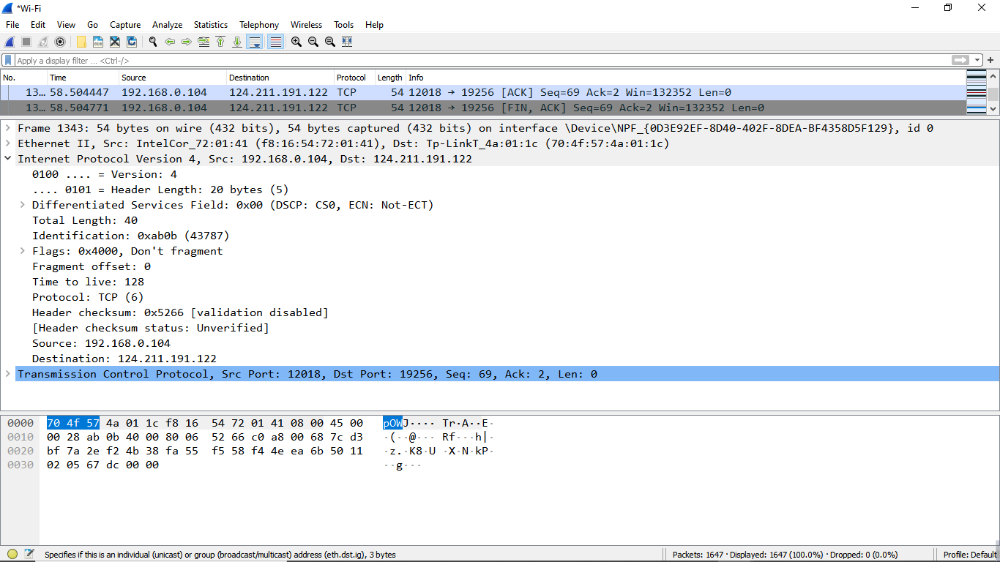

**Figure : Packet Details Pane(IP segment)**

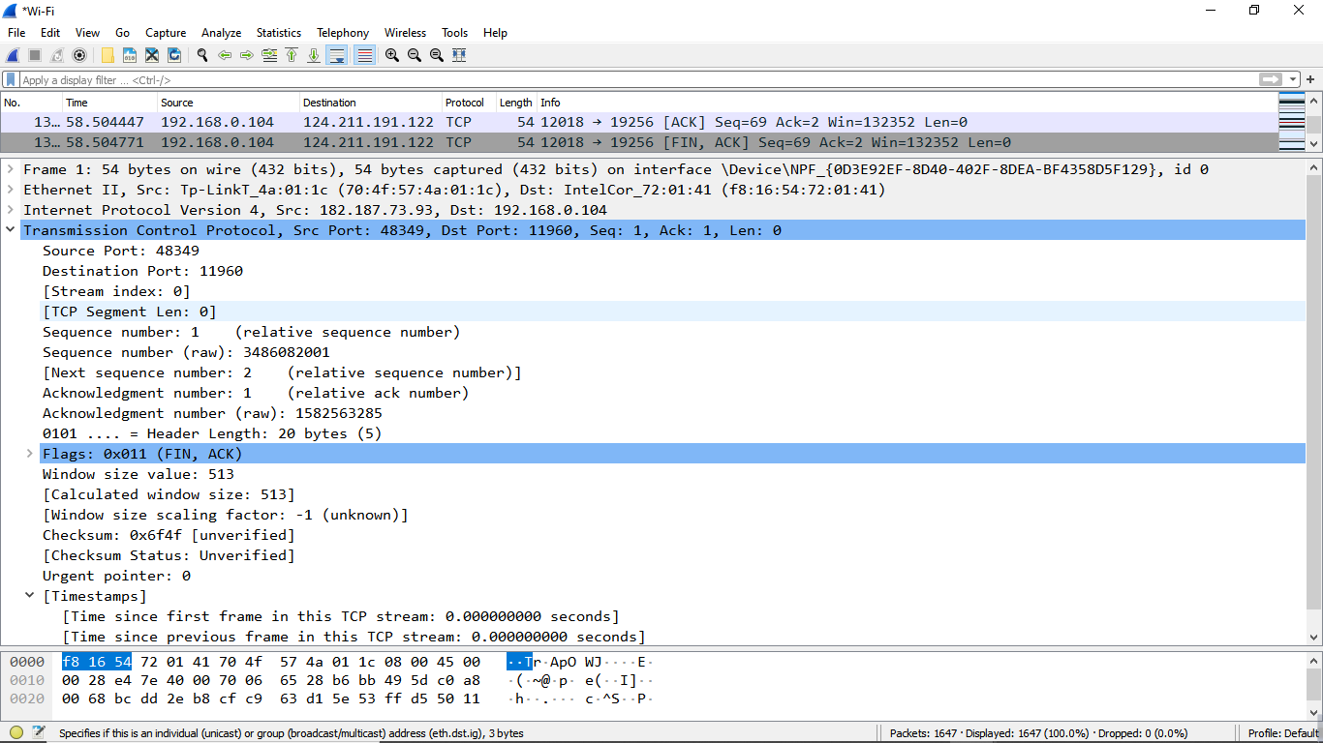

**Figure : Packet Details Pane (TCP Segment)**

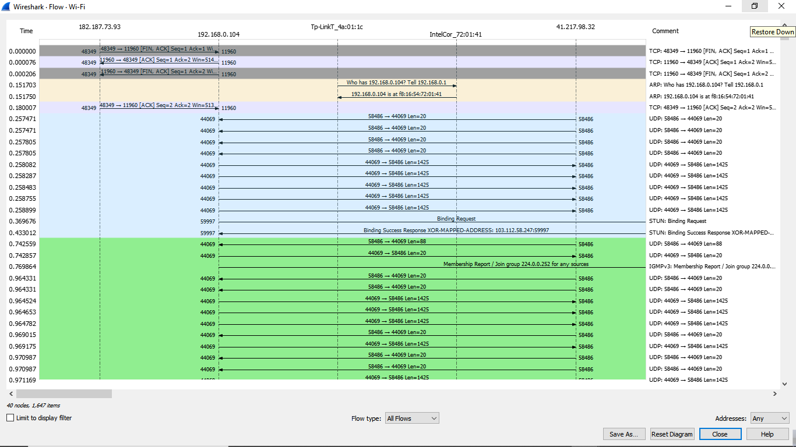

**Figure : Statistics- Flow Graph(All Flows)**

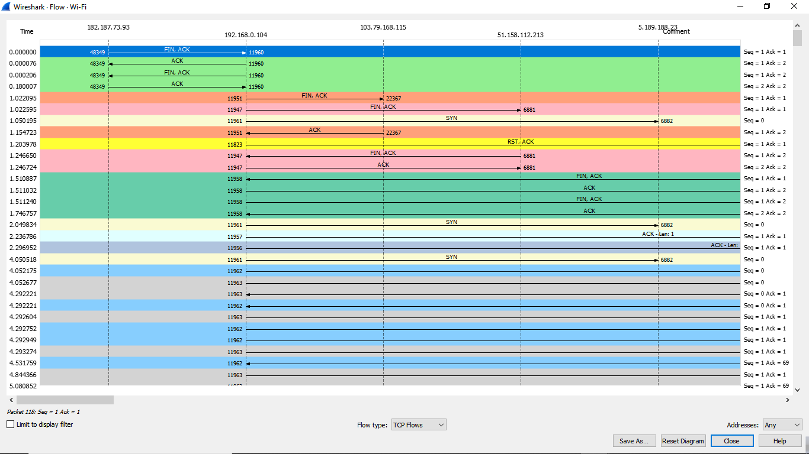

**Figure : Statistics- Flow Graph(TCP Flows)**